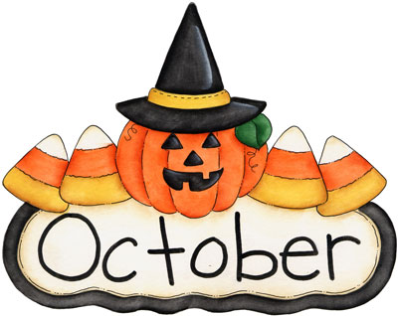

MONTH of October 2021
Sunday | Monday | Tuesday | Wednesday | Thursday | Friday | Saturday
 |  |  |  |  | 1. List the steps of how to wash your hands. | 2. Word of the Day! Use the word artistic in 2 different sentences.
3. Explain what “call it a day” means. Then use it in a sentence. | 4. Name 4 words that end with  “-ing”. | 5. Make a joke and tell 3 people. | 6. Name 5 things that are made of paper. | 7. Use the word “bat” two different ways by creating 2 different sentences. | 8. Share your favorite part of your day at dinner with your family using your best speech, language, and fluency. | 9. Word of the Day! Use the word wicked in 2 different sentences.
10. Play pretend as a ghost hunter. | 11. Tell the steps of how to carve a pumpkin. | 12. Name 3 words that rhyme with the word “sea”. | 13. Explain what “all ears” means. Then use it in a sentence. | 14. Explain how a bat and a witch are similar and different. | 15. Draw a picture of your Halloween costume and explain it. | 16. Word of the Day! Use the word pretend in 2 different sentences.
17. After listening to a book, answer WH questions to promote carryover. | 18. Act out in order:  1. Count to 10  2. Name favorite animal  3. Give 2 thumbs up | 19. Use the words: pumpkin, bat, and witch to create a scary story. Remember to use your best speech and language. | 20. Ask 3 people what their favorite candy is and why. | 21. Name 5 words that start with “S”. | 22. Use the word “ring” two different ways by creating 2 different sentences. | 23. Word of the Day! Use the word blush in 2 sentences
24. After watching a movie or TV show, retell what happened in the beginning, middle, and end.  31. Happy Halloween!  Share your favorite part of your day at dinner with your family. | 25. Name 3 words that rhyme with the word “dog”. | 26. Name 4 things that are orange. | 27. Share your favorite part of your day at dinner with your family. | 28. Name 5 things that are big. | 29. Name 3 words that rhyme with “treat”.  . | 30. Word of the day! Use the word sneaky in 2 sentences.

