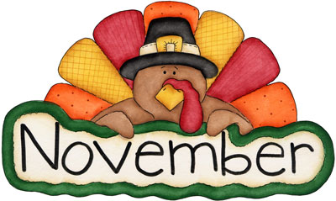

MONTH of November 2021
Sunday | Monday | Tuesday | Wednesday | Thursday | Friday | Saturday
 | 1. Name 5 things that can fly | 2. Look outside and describe what you see. | 3. Explain what “call it a day” means. Then use it in a sentence. | 4. Explain how a spoon and fork are different. | 5. Name 5 words that end with  “-ly” | 6. Word of the Day! Use the word match in 2 sentences.
7. Model good speech sounds and grammar at dinner. | 8. Name 3 words that rhyme with “bread”. | 9. Use the word “be” in a sentence, then use the word “bee” in a different sentence. | 10. Ask 2 people “would you rather live on a farm or live in a city?” | 11. Name 5 words that begin with “r”. | 12. List the steps of how to set the dinner table. | 13. Word of the Day! Use the word divide in 2 different sentences
14. Read a book aloud to a family member or friend. | 15. Explain how a chair and a table are similar. | 16. Name 5 things that are sweet. | 17. Use the words: turkey, table, and flying to create a silly story. | 18. Name 4 words that rhyme with “deer” | 19. Draw a picture of what you did on Thanksgiving and explain it to one person. | 20. Word of the Day! Use the word transportation in 2 sentences.
21. Play “I spy” with good speech sounds and grammar | 22. After listening to a book, answer WH questions to promote carryover | 23. Explain what “have mixed feelings” mean. Then use it in a sentence. | 24. Act out in order:  Spell your name  Spin around 2 times  Pat your head | 25. Happy Thanksgiving!  List things that you are thankful for. | 26. Make up a joke and tell 2 people. | 27. Word of the Day! Use the word giant in 2 sentences.
28. Explain the difference between clapping and snapping. | 29. Play pretend as a turkey farmer. | 30. Use the word “deer” in a sentence, then use the word “dear” in a different sentence.

