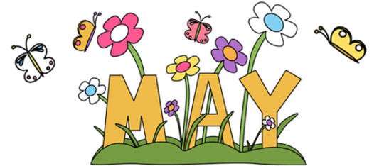

MONTH of May 2022
Sunday | Monday | Tuesday | Wednesday | Thursday | Friday | Saturday
1. Name 5 opposites. | 2. Play a matching game, such as “Go Fish” | 3. Name 5 items that are related to spring. | 4. Tell a joke to your parent or sibling. | 5. Help make dinner by following a recipe and discussing the steps | 6. Name as many animals as you can. | 7. Word of the Day! Use the word daily in 2 sentences.
8. Mother’s Day  Read a book to mom | 9. Play 2 rounds of “Simon Says” | 10. Name an object for every letter of the alphabet | 11. Read a story out loud to a friend of family member | 12. Find 5 things that are the color black. | 13. Discuss the multiple meaning of the following words:  1. pet  2. spring  3. be/bee | 14. Word of the Day! Use the word sibling in 2 different sentences.
15. Draw a picture and describe it with your best speech and language | 16. Share a part of your day at dinner. | 17. Look out the window and describe what you see. | 18. Name 3 words that rhyme with:  Book  Shop  Fun | 19. Discuss what “Beat around the bush” means | 20. Create a story that has the following words in it:  monster, grass, degree, map | 21. Word of the Day! Use the word batch in a sentence.
22. Ask questions to promote carryover | 23. Think of as many words as you can that start with “S” in one minute | 24. Use the word ate in a sentence and eight in a different sentence. What is the difference? | 25. Name 6 words that have /ch/ sound in them. | 26. Draw a picture and describe it. | 27. Play “I Spy” with your best speech and language | 28. Word of the Day! Use the word honest in 2 different sentences.
29. Explain what “raining cats and dogs” means. | 30. Memorial Day!  Define was FREEDOM means to you with your best speech and language skills. | 31. Name 5 opposites. |  |  |  | 29. Word of the Day! Use the word rise in 2 different sentences.

