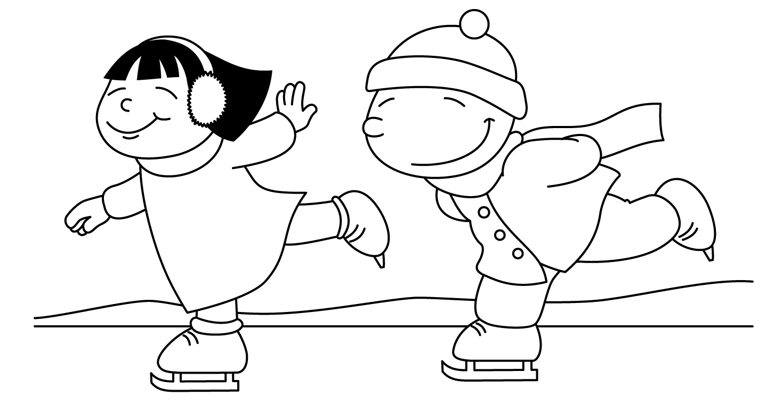

MONTH of JANUARY 2022
Sunday | Monday | Tuesday | Wednesday | Thursday | Friday | Saturday
1. Happy New Year!
Finish this sentence “My New Year’s resolution is…”
2. Name 2 things you ate for lunch | 3. Make up a story about winter | 4. Name 3 things you find in a bedroom | 5. List your favorite:  Color  Animal  Food  Song | 6. Describe a snowman.  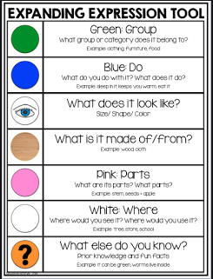 | 7. Name 5 fruits you find at the grocery store | 8. Word of the Day! Use the word freezing in a sentence.
9. Name things you see while in the car | 10. Act out in order:  Jump  Hop  Wink  Skip | 11. Tell one thing you did today at school | 12. Name all of the people you can in one minute | 13. Read a story out loud to a friend or family member | 14. Draw a picture and describe it | 15. Word of the Day! Use the word howl in a sentence.
16. Make up a joke and practice telling it to family and friends | 17. Name at least 5 types of occupations | 18. List 5 things in the refrigerator | 19. Name 3 words that rhyme with:  Ball  Cat  Sock | 20. Share part of your day at dinner | 21. Take a walk outside and describe what you see | 22. Word of the Day! Use the word yank in a sentence.
23. Ask questions to promote carryover after reading a book together.  30. List 5 things in your toy box | 24. Think of as many words as you can that start with “J” in one minute  31. Would you rather be able to fly or be invisible? Why? | 25. Describe a car. | 26. Tell the steps you take to make a peanut butter and jelly sandwich | 27. Name a month that is cold and one that is not cold | 28. Name things you find in and on trees. | 29. Word of the Day! Use the word freezing in a sentence.

