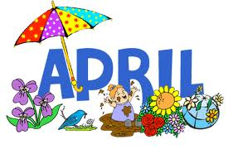

MONTH of APRIL 2022
Sunday | Monday | Tuesday | Wednesday | Thursday | Friday | Saturday
 |  |  |  | 1. April Fools! Tell someone a joke. | 1. April Fools! Tell someone a joke. | 2. Word of the Day! Use the word apologize in 2 different sentences
3. Read a book and then explain your favorite part | 4. Describe how a pencil and a pen are similar. | 5. Name 6 animals that live in the woods. | 6. Name the colors of the rainbow. | 7. Name 5 words that end with “R” | 8. Model good speech sounds and grammar | 9. Word of the Day! Use the word basket in 2 different sentences
10. Play “I Spy” in the car taking 4 turns each | 11. Share a part of your day at dinner | 12. Make a story up about a rain storm. | 13. Name 5 things that are fast. | 14. Describe what you see outside. | 15. Name all the objects associated with baseball. | 16. Word of the Day! Use the word sob in 2 different sentences
17. After listening to a book, ask and answer questions about it. | 18. After listening to a book, ask and answer questions about it. | 19. Explain the steps on how to tie your shoes | 20. Play 20 Questions | 21. Name 4 words that rhyme with “bat” | 22. Name 5 sports | 23. Word of the Day! Use the word mask in 2 different sentences
24. After watching a movie, describe what happened using first, then, and finally | 25. Describe the difference between a cat and a dog | 26. Name 5 words that begin with “S” | 27. Explain the steps to play hide-n-seek | 28. Name 5 words that begin with “G”. | 29. Name 4 words that rhyme with “told” | 30. Draw a picture and describe it

